Department of Materials and Metallurgical Engineering
Indian Institute of Technology

Kanpur

DST – Fund for Improvement in S&T Infrastructure

Brief Outline Department

Department of Materials and Metallurgical Engineering (MME) has been very active in teaching, research, development and consultancy activities in entire spectrum of materials science, starting from extraction, processing, and development of materials. Development of innovative systems and processes today depends more and more on the availability of high performance materials. This department has pioneered a unified approach in teaching and research to develop state-of-the art materials and processes for specialized applications.
Teaching & Research Activities
We are a leading department in the country for developing a quantified approach to materials education and research. The department offers both Undergraduate (B.Tech.) and Postgraduate (M.Tech. and Ph.D.) programs. The undergraduate program is aimed at providing a basic understanding of the principles underlying metal extraction and refining, materials characterization, structure-property relationships, and processing of metals and other materials. Students also undertake studies of their special interest through the department elective courses and project work. In addition to the fundamentals of materials engineering, the Postgraduate program is designed to provide an in-depth study in the area of specialization of the student.

Facilities Created

The Electron Microscope Facility (EM Facility) comprises a FEI Technai 20 U Twin Transmission Electron Microscope. The microscope is a STEM and is also equipped with a EDS system of EDAX make, HAADF detector and Gatan make high resolution digital CCD imaging system.

Funding

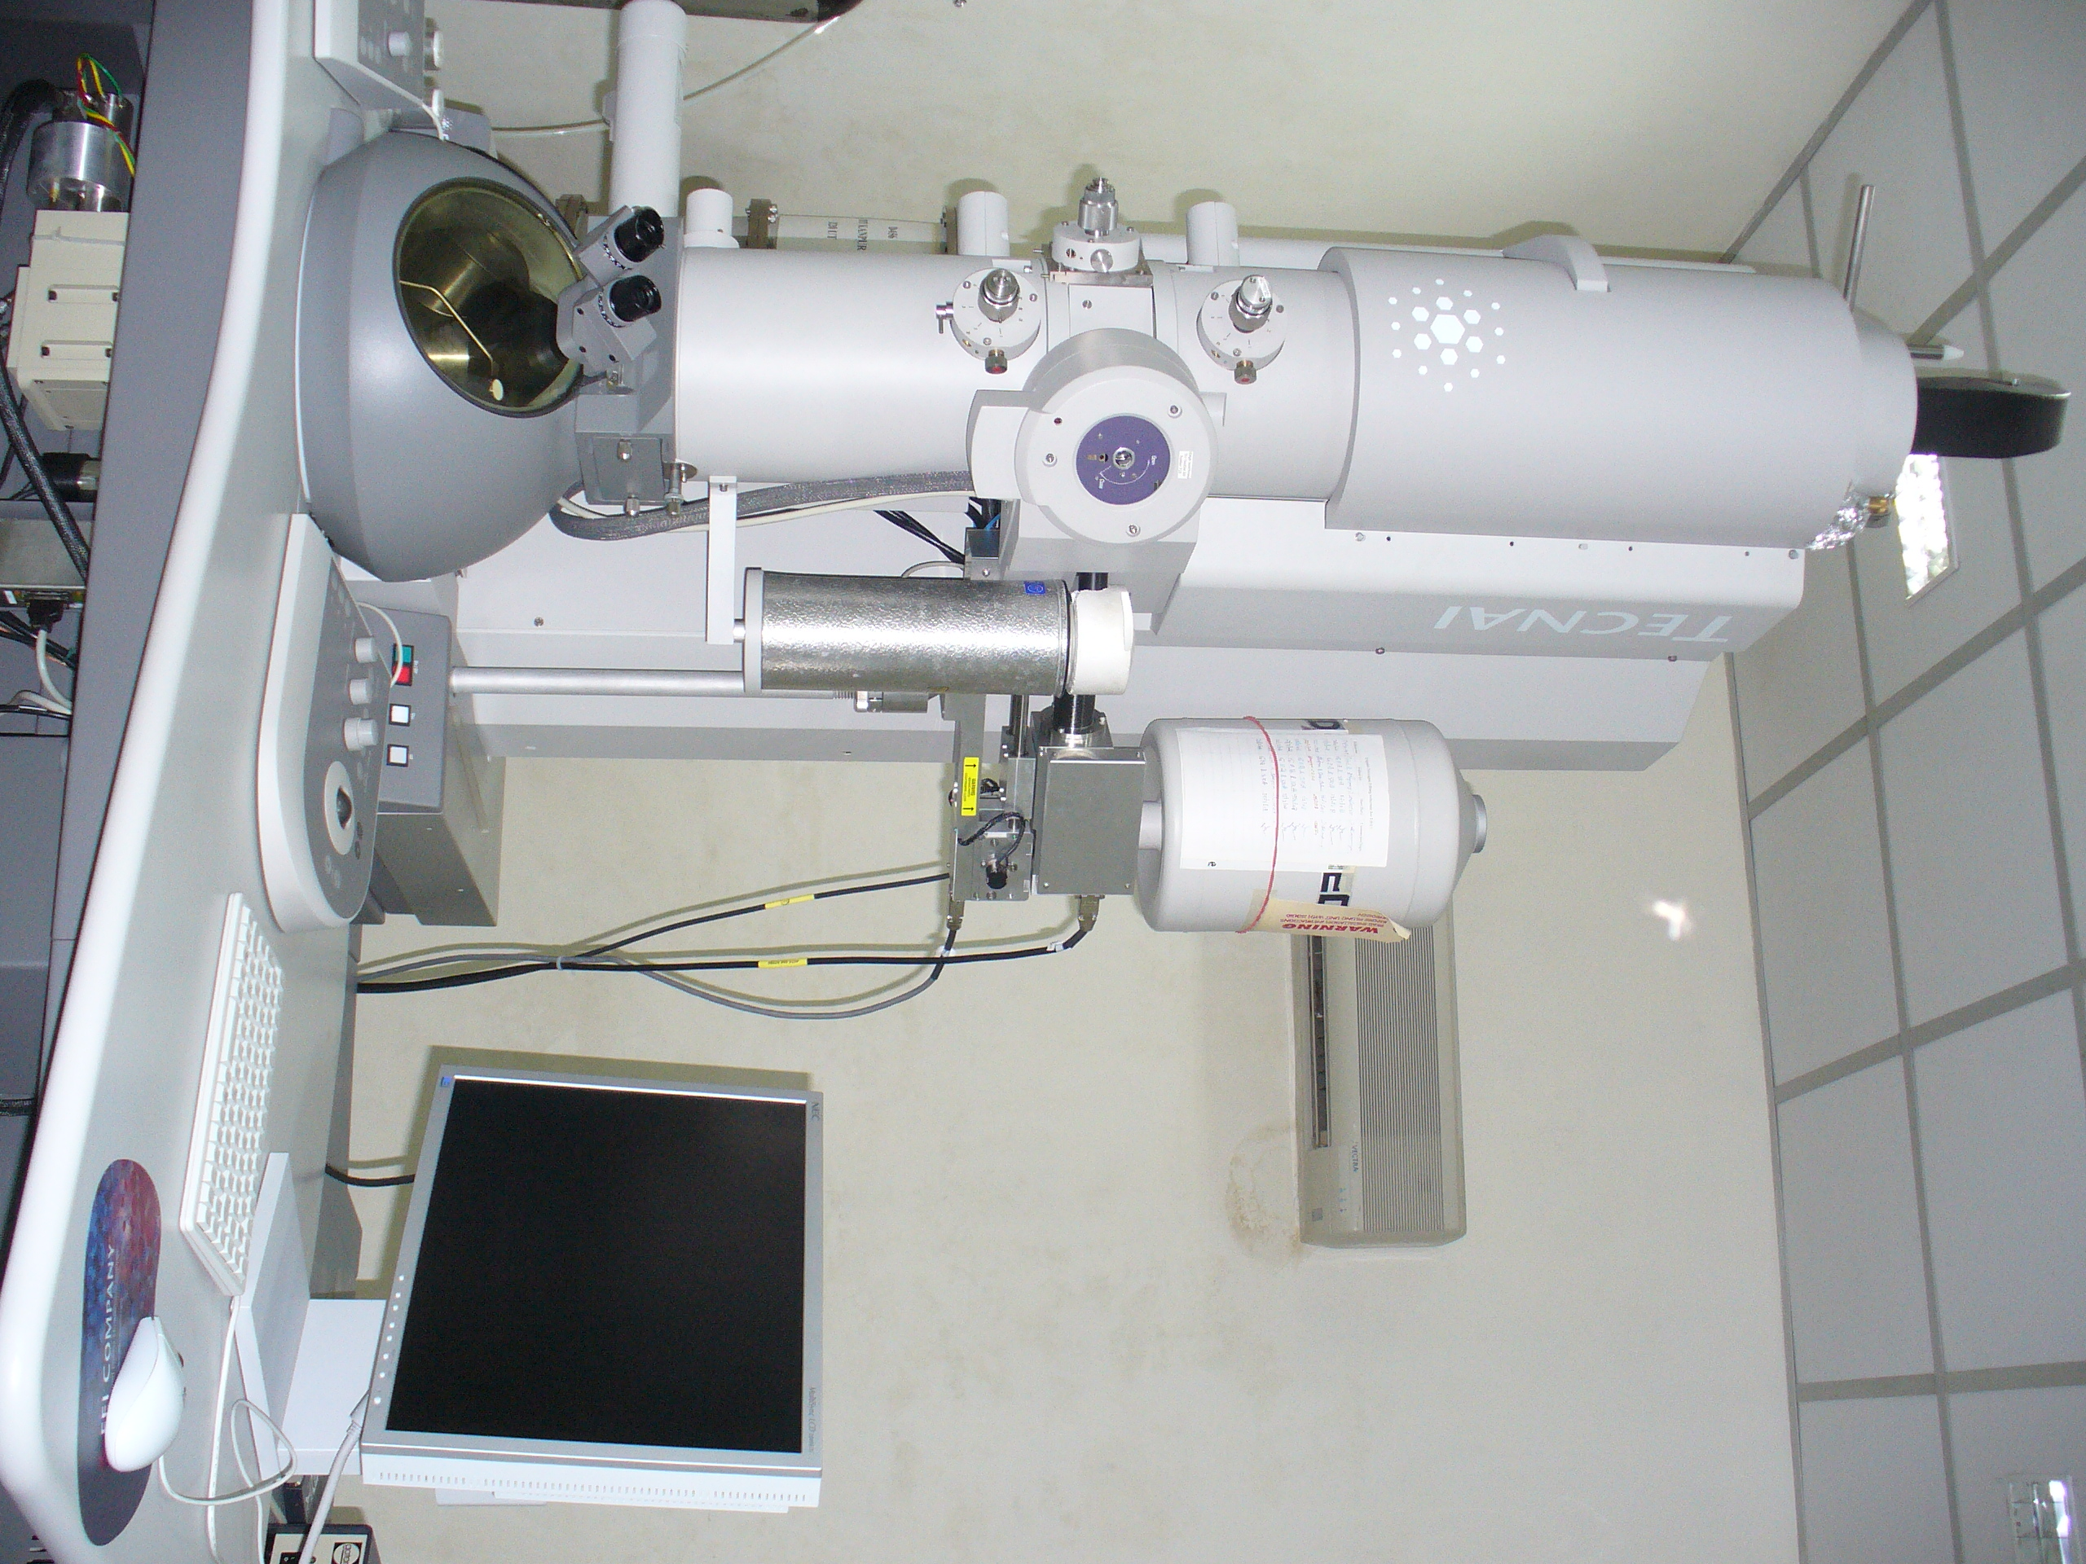

For details about the Facility visit: http://www.iitk.ac.in/mme/TEM%20lab/index.htm

For further details contact:

Professor Rajiv Shekhar
Head, Materials and Metallurgical Engineering
Indian Institute of Technology
Kanpur 208 016
E-mail: vidtan@iitk.ac.in
Ph.No: 0512-2597505
Fax No : 0512-2597505/0512-3927505

Dr. Gouthama
Convener,
Electron Microscopy Facility
Materials and Metallurgical Engineering
Indian Institute of Technology
E-mail: gouthama@iitk.ac.in
Ph.No: 0512-2597450

For further details contact:

Dr. Gouthama
Assistant Professor
Materials and Metallurgical Engineering
Indian Institute of Technology
Kanpur

Dr. Gouthama
Convener,
Electron Microscopy Facility
Materials and Metallurgical Engineering
Indian Institute of Technology
Kanpur Professor ------------------- Tel. No. --------------- (o), --------------- ®
Head/ Coordinator Fax no.
Email ID.
Department/ School of ------------------
[Address]

