Department of Applied Mechanics
Dept. of Applied Mechanics
IIT-Madras

DST – Fund for Improvement in S&T Infrastructure(FIST 2000)

.

Brief Outline Department

The Department of Applied Mechanics, IIT Madras, started in 1959, has at present a faculty strength of 14. The activities of the department are organized into 3 groups viz. Biomedical Engg, Fluid Mechanics and Solid Mechanics. The Department primarily functions as a graduate research department, at the same time, also offering a number of basic undergraduate courses related to mechanics. The faculty of the department has won laurels in research, teaching & industrial consultancy. The vision of the department is to be a frontier knowledge base that will translate advances in basic sciences in solving challenging problems in Engg. and Science.

Teaching & Research Activities

The department trains the students in the fundamentals and application of Mechanics through its M.S (by research), M.Tech and Ph.D programmes. The department also offers basic Mechanics courses and minor streams to undergraduate students of the institute. Since 1995, the department has awarded 259 M.Tech, 87 M.S and 165 Ph.D degrees. Research, both fundamental and applied, is conducted in various areas like digital photo elasticity, turbulence modeling, smart materials, fracture, haptics, biomedical signal processing, biomaterials, jets and shear layers, convection etc. The research excellence of the department is reflected in the 190 international journal publications, 270 conference publications, and the 12 books published by the faculty since 1995.

Facilities Created

Using the funding from DST under the FIST programme the following facilities have been created

- Stereoscopic particle imaging velocimetry (PIV) system.
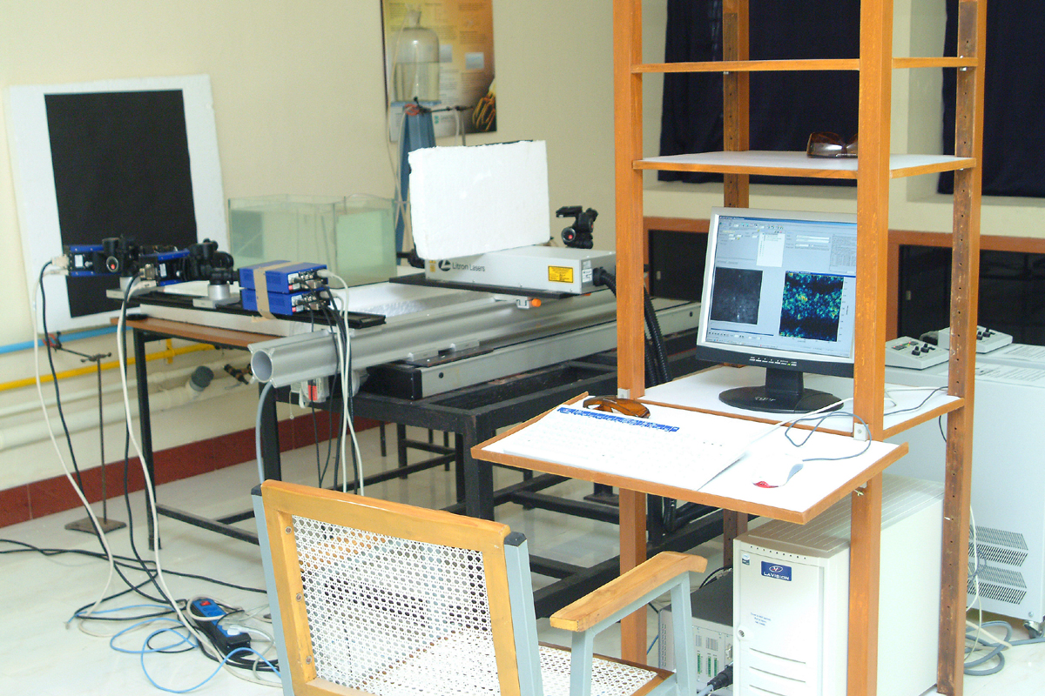
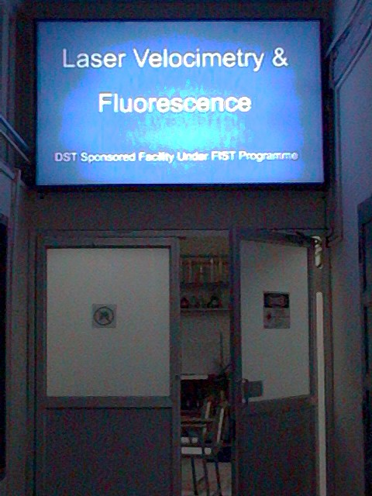

Laser velocimetry and fluorescence laboratory
A view of the PIV system
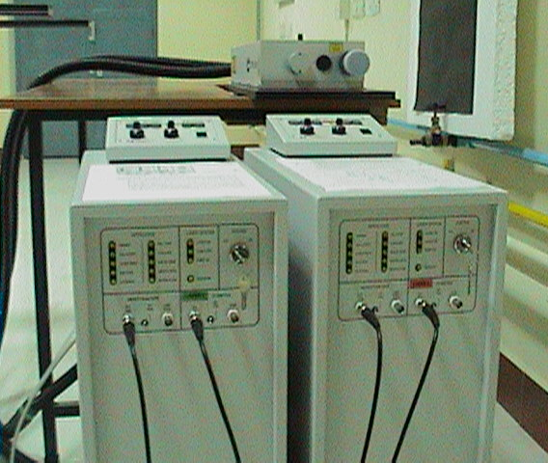
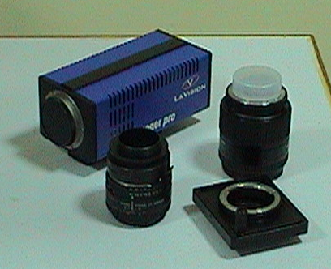
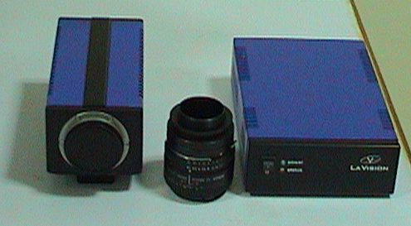
Image Pro X 4M CCD Camera

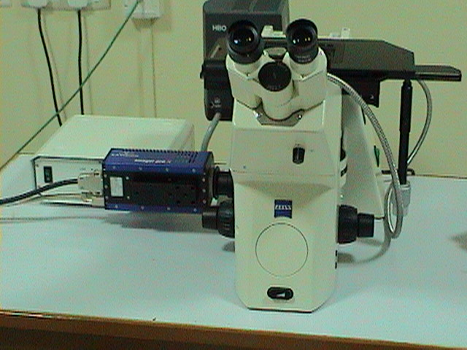
Microscope with CCD Camera attached

Major components of the PIV system
Zoom lens

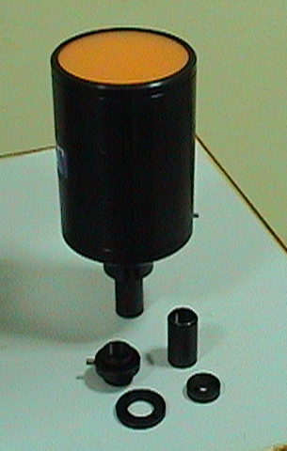
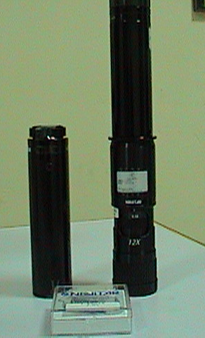
Diffuser

Nd: YAG Double Cavity Laser

Image Pro HS CMOS Camera with Scheimpflug Mount

Synchronization Board
Linear and Translation Unit
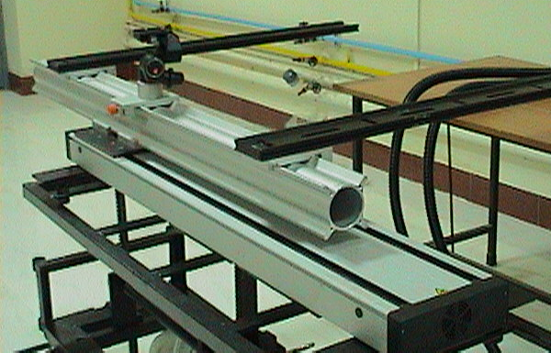
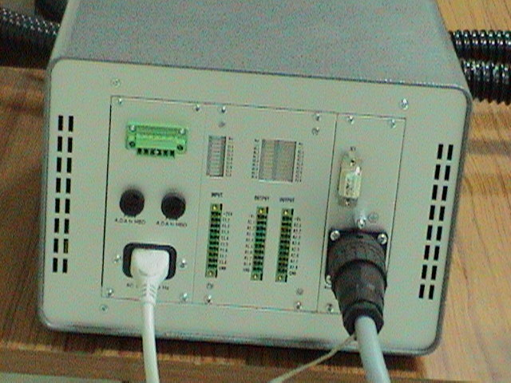

2. Peripherals

B. Peripherals

B1. Item Power Backup System – UPS

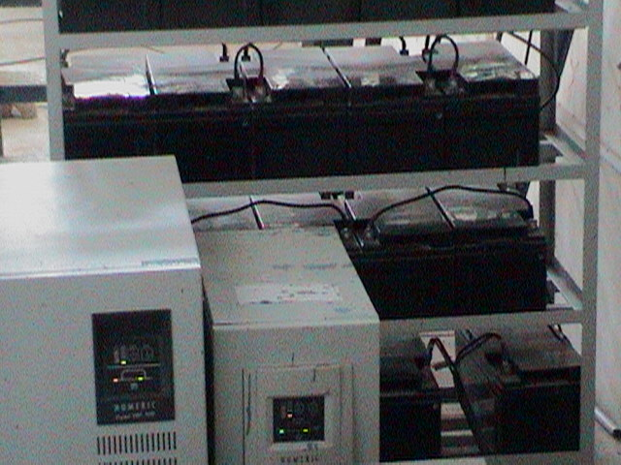
B2. Air Conditioner
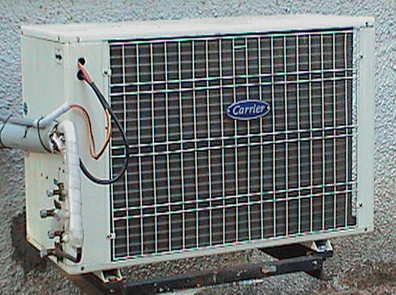
10kVA, 3Ph-1Ph Numeric Digital HP series IGBT true on-line UPS system, 60 min battery back using 20 12V/65/75 Ah external SMF battery
3.0 TR ductable split AC

- 230 kW AC motor and AC drive panel for the low speed tunnel.

AC motor
AC Drive panel for controlling the AC motor.
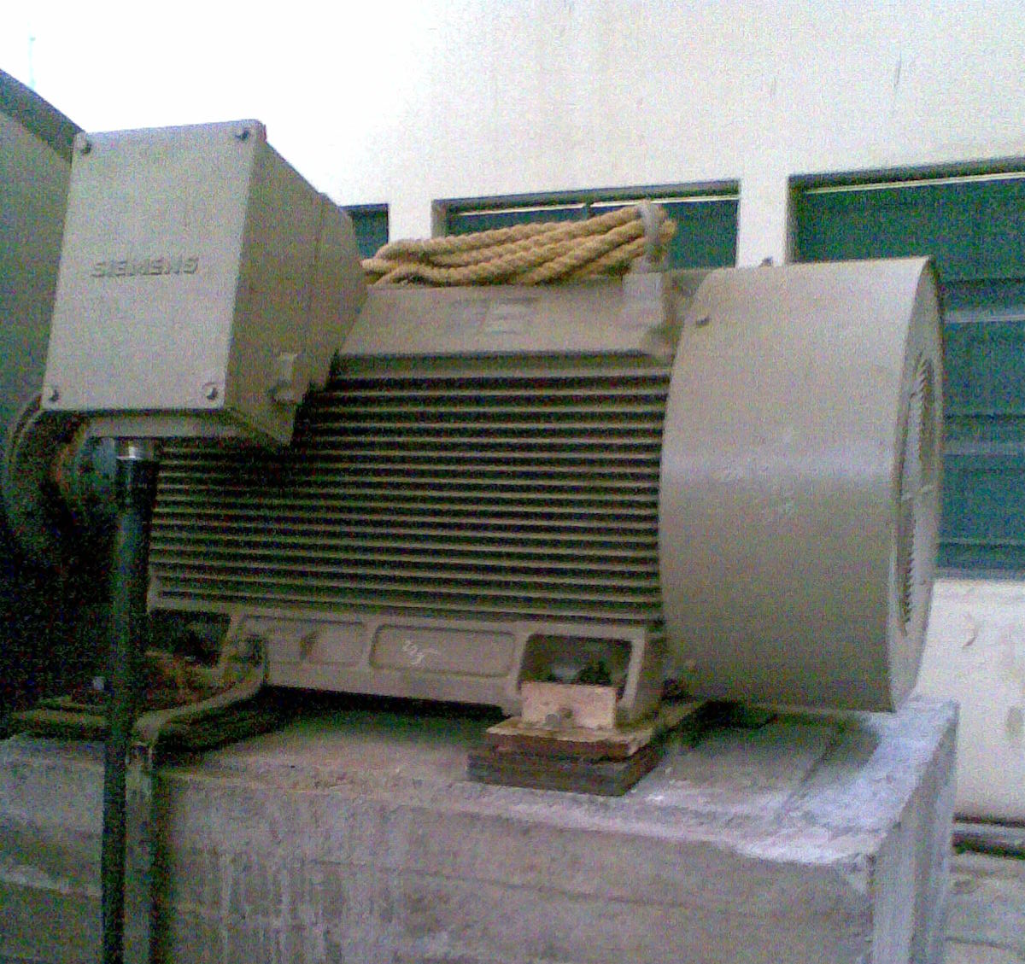
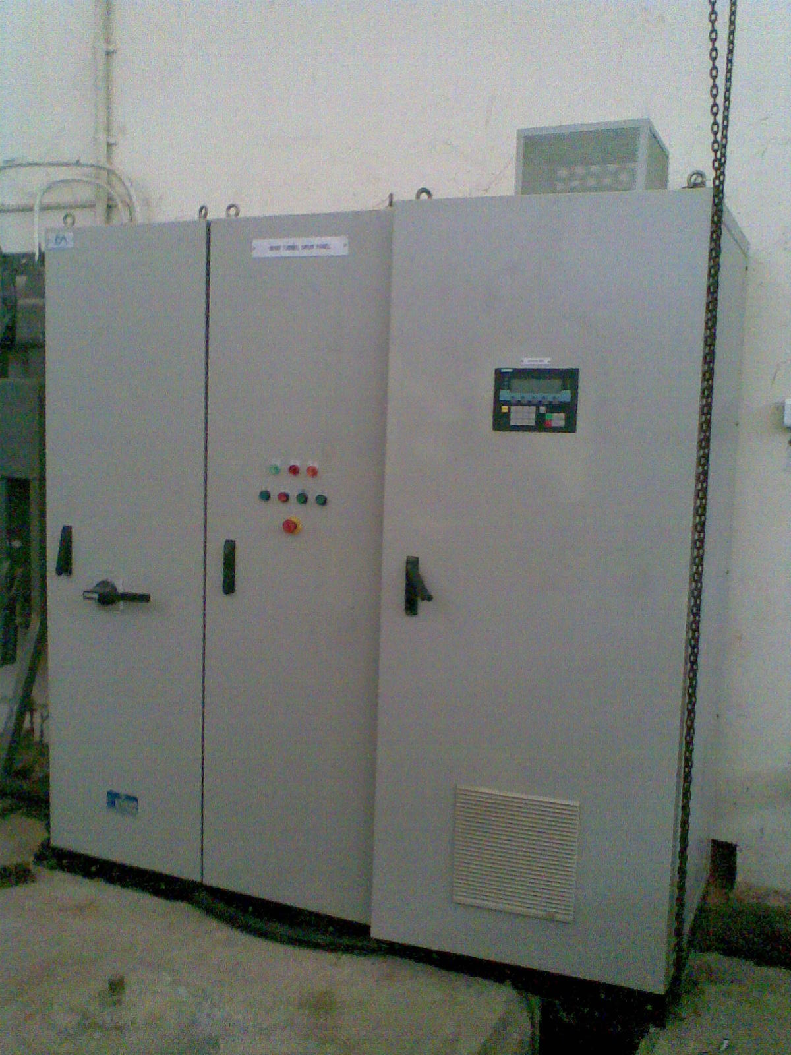

230KW, 8P, 750RPM, Horizontal foot mounted motor with forced cooling, insulated bearing and VPI coating

230KW AC drive system with Siemens make VSD Sinamic G130 with suitable encloser

For further details contact

Prof. K.Ramesh
Head/Coordinator
Head, Dept. of Applied Mechanics

IIT-Madras, 3600036

Email ID. kramesh@iitm.ac.in
Tel No.2257 4051
Fax No. 2257 4052

