Department of Ocean Engineering
Indian Institute of Technology Madras,
Chennai

DST – Fund for Improvement in S&T Infrastructure (FIST 2000)

Brief Outline of the Department
The then Ministry of Education and Social Welfare, as per the decision of Council of Indian Institute of Technology, established the Ocean Engineering Centre of IIT Madras in 1977 based on the recommendation of the committee headed by Dr. Y. Nayudamma. The Department is to act as a Department of Excellence for advancing the frontiers of science and to provide 'Break-through Technology' as well as to develop education and training programs in the field of Ocean Engineering. A national advisory Committee consisting of representatives of the then Ministry of Education, CSIR, UGC, DST, ONGC, EIL, other IITs and user industries with the Director, IIT Madras as the chairman monitored the progress of the Department over the years. A review committee headed by the Prof. M.G.K. Menon also reviewed the progress of the Department in 1982 and its recommendation have since been implemented. The Department has been functioning as an academic department since 1982.
Teaching and Research Activities
The Department of Ocean Engineering is mainly focused in teaching at B.Tech, M.Tech, M.S and Ph.D levels in the field of Naval Architecture and Ocean Engineering. At any time, a total number of about 200 student pursue their studies at the department and about 40-50 students graduate from the department. The department has the following missions:
- To create infrastructure and expertise in order to carry out R & D work in areas of Ocean Engineering and related fields which have direct relevance in the national context.
- To create educational and research opportunities at graduate and doctoral levels.
- To extend educational facilities and train the manpower from industry, R & D organisations and other educational institutions in order to enable them to carry out tasks areas of Ocean Engineering.
- To collaborate with user organisations on need based problems

The last 25 years have seen a remarkable growth of the Department in terms of expertise and infrastructural facilities and there has been notable success in achieving the above mentioned objectives. The Department vigorously pursues activities in line with its objectives and remains committed to excellence in its endeavor in education, research and training programs as well as supporting developmental efforts of marine industries. The Department has laboratory area of about 3000 sq. m. and a highly specialised faculty numbering 20 with adequate support from technical and administrative staff.
Areas of Research
- • Analysis, Design and Testing of Offshore, Port and Harbour Structures
- • Coastal Processes and Coastal Engineering
- • Ships, Floating Platforms and Submerged Bodies
- • Marine Geotechniques
- • Materials in Marine Environment
- • Ocean Energy

Facilities Created & Funding
Sl. No. | Major and sub items
I | Small Flume (Glass Flume)
II | Shallow Water Basin
III | Six Component Motion Measuring System
IV | Propeller Dynamometer
V | MEWM Control System upgradation
VI | Ultrasonic Current Meter
 | Total

For further details contact:
Head of the Department, Department of Ocean Engineering, Indian
Institute of Technology Madras, Chennai 600 036.
Ph: 044 22574801; Fax: 044 22574802; e-mail: headoec@iitm.ac.in
Details of Equipment acquired under FIST Program
Name of the Equipment | Propeller Dynamometer
Model Number | R31-01
Complete Specifications | Propeller Dynamometer for carrying out Propulsion test with ship model
Details of Manufacturer
Name | Cussons Technology Ltd
Address | 102, Great Clowers Street  Manchestor M7 1RH, England
City | England
PIN | PO122AU
State
Phone | 0161 8330036
Fax | +44 2392 603961
Email | kempf@cussions.co.uk
Details of Local Agent /  Supplier | -
Address | -
City | -
PIN | -
State | -
Phone | -
Fax | -
Email | -
Used for | Carrying out propulsion test with ship model

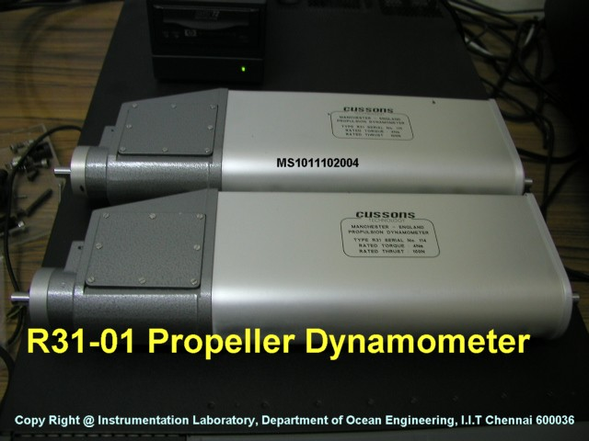
Scanned Photograph of the Equipment (Front view)
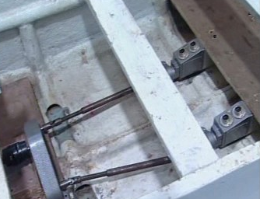
R31-01 Propeller dynamometer fixed to the model
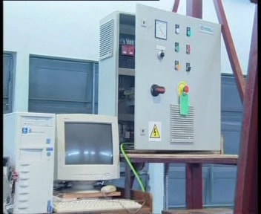
Feedback control drive cubicle

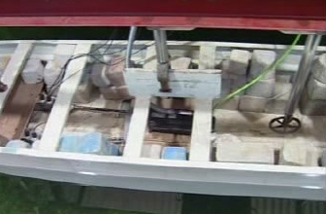
Propeller dynamometer and servo motor fitted to a model under testing conditions
Details of Equipment acquired under FIST Program –

Pro-reflex System
Name of the Equipment | ONE 2 – Camera Pro-reflex System
Model Number
Complete Specifications | One – 2 – Camera Pro-reflex system MCU 240 MHz, Pro-reflex
Details of Manufacturer
Name | Optomatrix Technology, AB
Address | Esperantoptasten, 7-9, 41119  Goleborg, Sweden, VAT No. SE556617216801
City | SWEDEN
PIN
State
Phone | +46(0)31-774 3830
Fax | +46(0)31-774 3835
Email | sales@optomatrix,se
Details of Local Agent /  Supplier | -
Address | -
City | -
PIN | -
State | -
Phone | -
Fax | -
Email | -
Used for | Measuring 6 DOF in our wave basin and rigid body motion measurement where the body may be fixed, floating or compliant
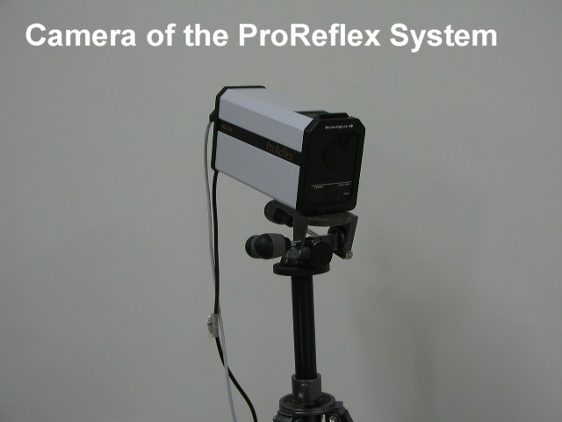

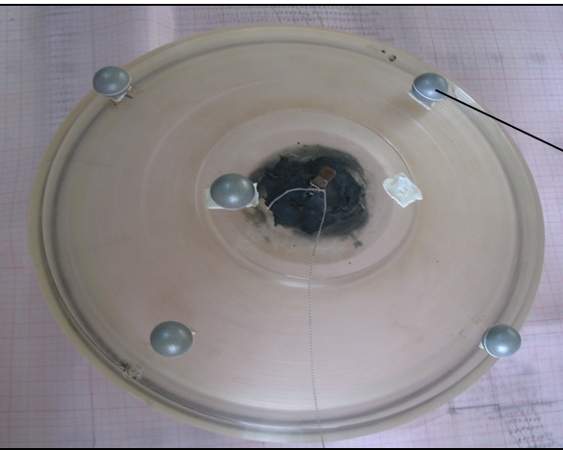
Passive marker fitted on to a model

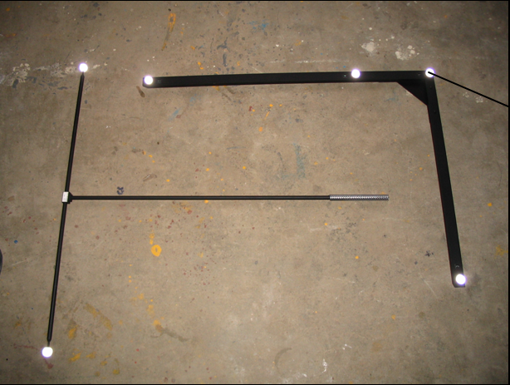
Passive marker fitted on to a calibrating frame and wand
A.1 Glass Flume ( Infrastructure development)
Glass Flume Lab at the Department of Ocean Engineering

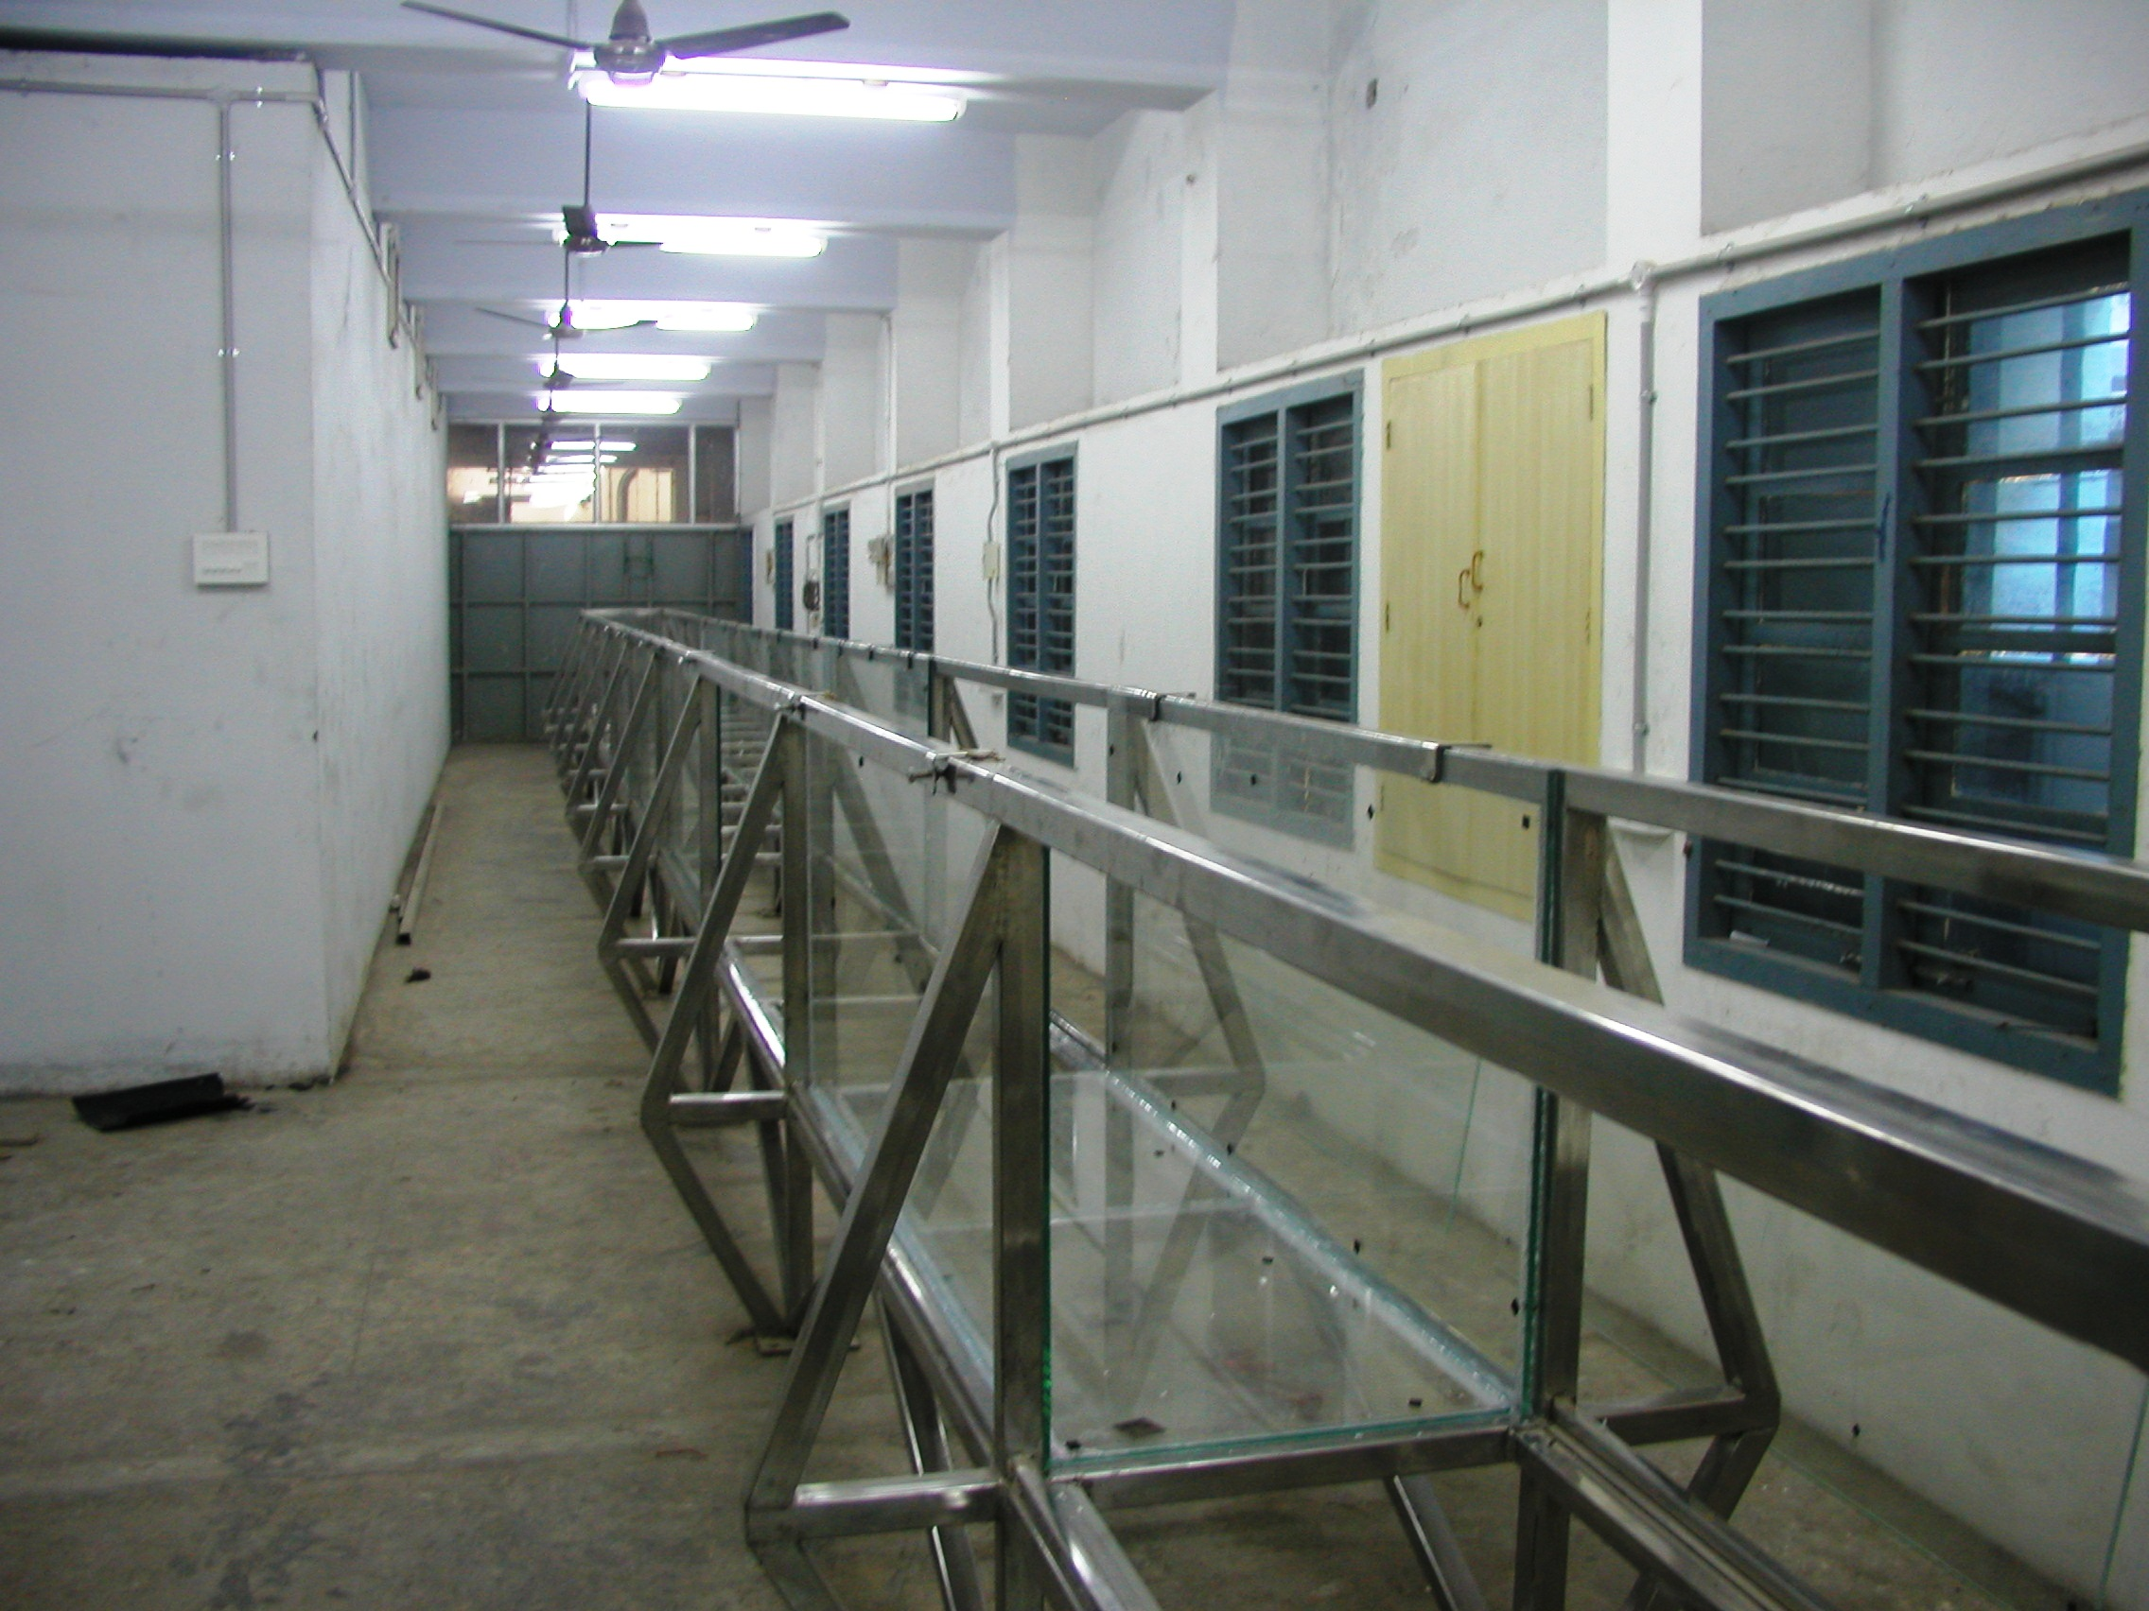
A.2 Shallow Water Basin
(Length 19.7m; Width 16.5m & Depth 0.45m and Moveable bed)
Waves: Periods – 0.5-1.5s & Height – up to 30 cm 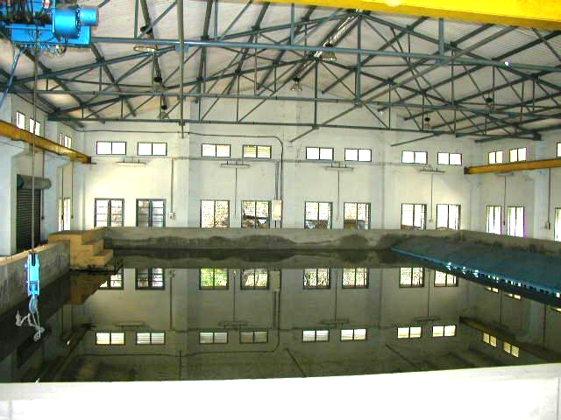A View of the Shallow Water Basin (Feb’2008)

