Department of Materials Science
Sardar Patel University
Vallabh Vidya Nagar

DST – Fund for Improvement in S&T Infrastructure (FIST 2000)

Brief Outline Department

The Department set up in 1990, has been recognized as Centre for Advanced Studies in Materials Science by UGC, New Delhi, and as Centre for Excellence in Nanomaterials and Nanotechnologies by the Govt. of Gujarat, International Collaboration linkages with USA, Germany, Japan, Korea. The main functions of the Department are Teaching and Research and consultancy in the field of Materials Science, particularly carbon, ceramics and related materials. It is equipped with advanced and sophisticated equipments for processing of materials, chemical analysis, microstructural analysis, mechanical, thermal and optical properties.

Teaching & Research Activities

The Department runs Post Graduate programs (M.Sc. and Ph.D) in Materials Science, Materials Technology and NanoScience and Nanomaterials. The R & D Thrust areas of the Department are Solid as well as porous Carbon and Ceramics, high temperature composites; activated carbon, metals-carbon composites, Carbon nanotubes and nanoclays, flyash composites etc. The Department also provides R&D, testing and consultancy services to educational, research organisation and industries. The Department is having research collaboration with U.S.A., Japan and Germany.

Facilities Created

The Department is equipped with Heat treatment Furnaces upto 1000ºC, 1750ºC and 2500ºC, Laboratory scale spray drier, Dynisco Mini mix Extruder and spin coater. The characterization equipments include Mettler Thermal Analysis System TA 4000 up to 1000ºC, Shimadzu UV-Visible Spectrophotometer, Shimadzu FTIR 8300 Spectrophotometer, Instron Universal Testing Machine 5500, Micromeritics Gemini BET Surface Analysis System, Scanning Electron Microscope Hitachi S-3000N, Leitz Optical Microscope Metloplan 12POLS, Renishaw in Via Raman Microscope, Micromeritics ASAP 2020 Surface Area and Porosity Analyzer, Keithley made electrical properties measurement instrument(model-6221, 2182A, 6517A) etc.

Funding

Major funding of the Department comes from Gujarat State Govt., U.G.C., DST, DAE, DRDO, National Fusion Program etc.

For further details contact:

Professor Lalit M. Manocha
Head & Coordinator
Department of Materials Science
Sardar Patel University
Vallabh Vidya Nagar-388120

Tel. No. O2692-235183/ 226853 (o), 02692-236713 ®
Fax no. 02692 235183
Email ID. manocha52@rediffmail.com
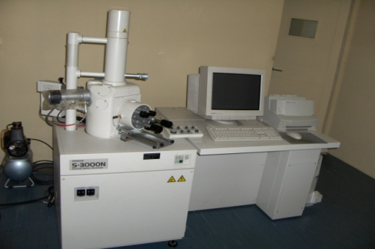
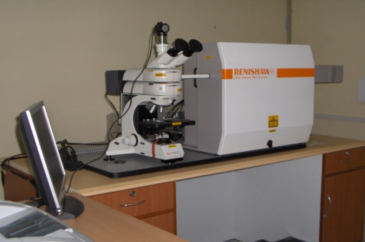
Scanning Electron Microscope Hitachi S-3000N
Renishaw in Via Raman Microscope
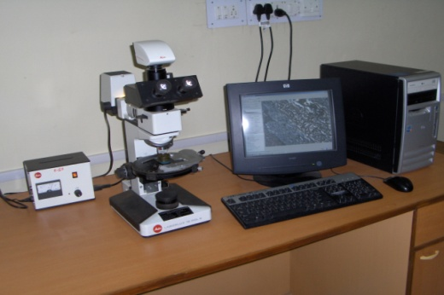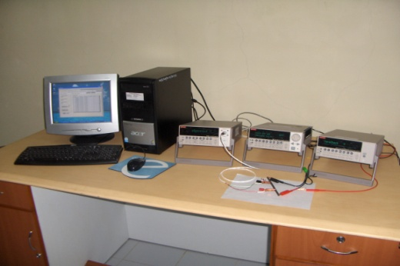
Leitz Optical Microscope Metloplan 12POLS
Keithley electrical properties measurement instrument(model-6221, 2182A, 6517A) etc.
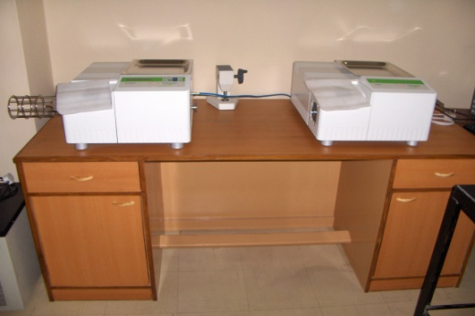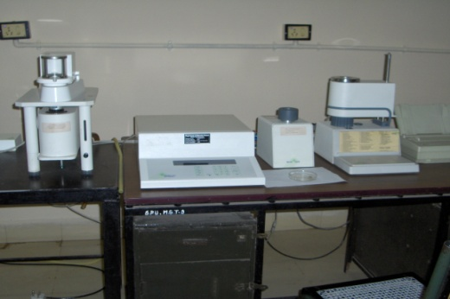
Mettler Thermal Analysis System TA 4000 up to 1600 ºC
Mettler Thermal Analysis System TA 4000 up to 1000 ºC
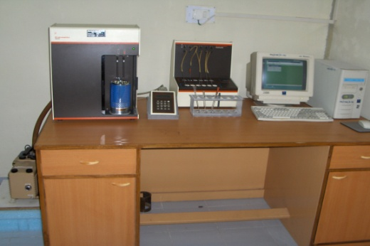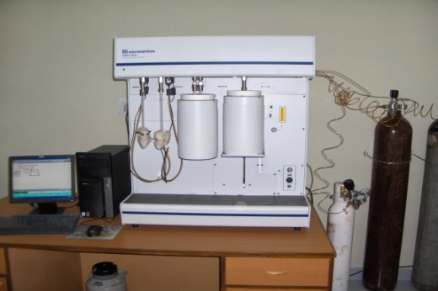
Micromeritics Gemini BET Surface Analysis System
Micromeritics ASAP 2020 Surface Area and Porosity Analyzer

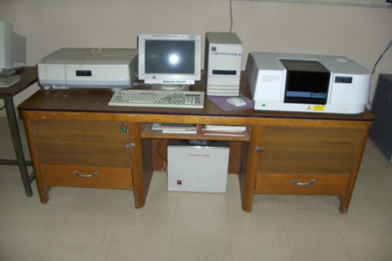
Shimadzu UV-Visible and FTIR 8300 spectrophotometer

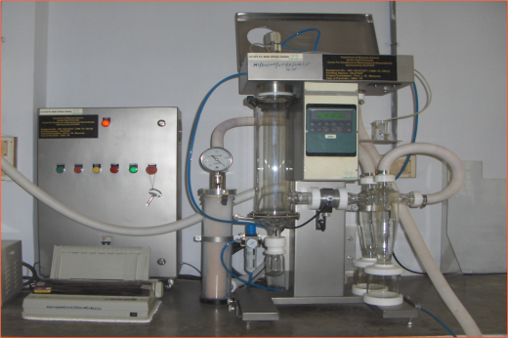
Laboratory scale spray drier (Labultima) ()

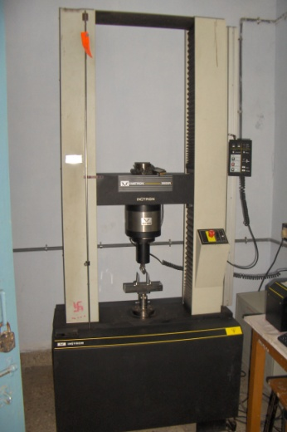
Instron Universal Testing Machine 5500

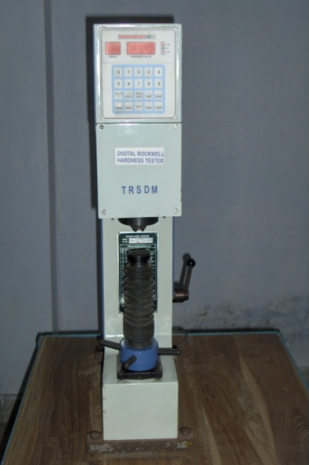
Digital Rockwell Hardness Tester

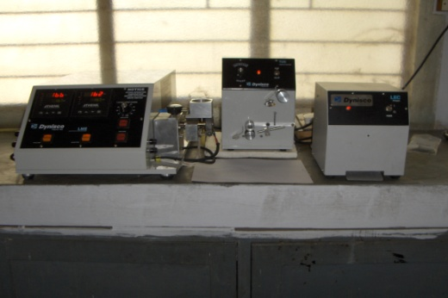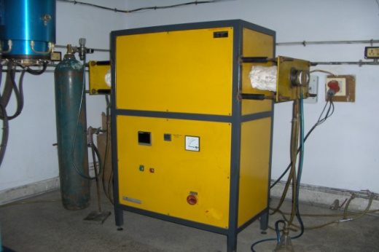
Dynisco Mini mix Extruder
Agni Furnaces upto 1800ºC

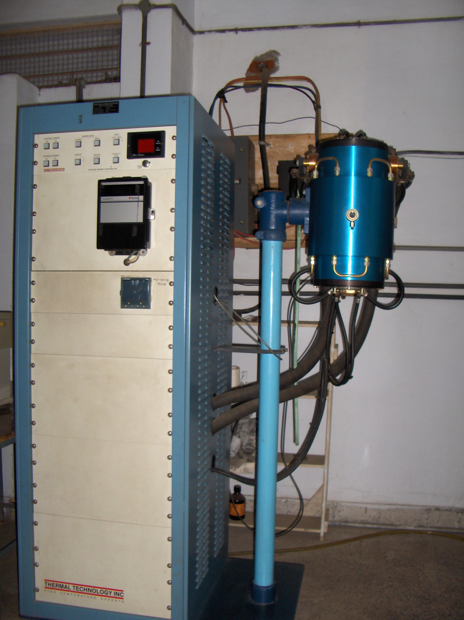
Graphitization Furnace upto 2800ºC

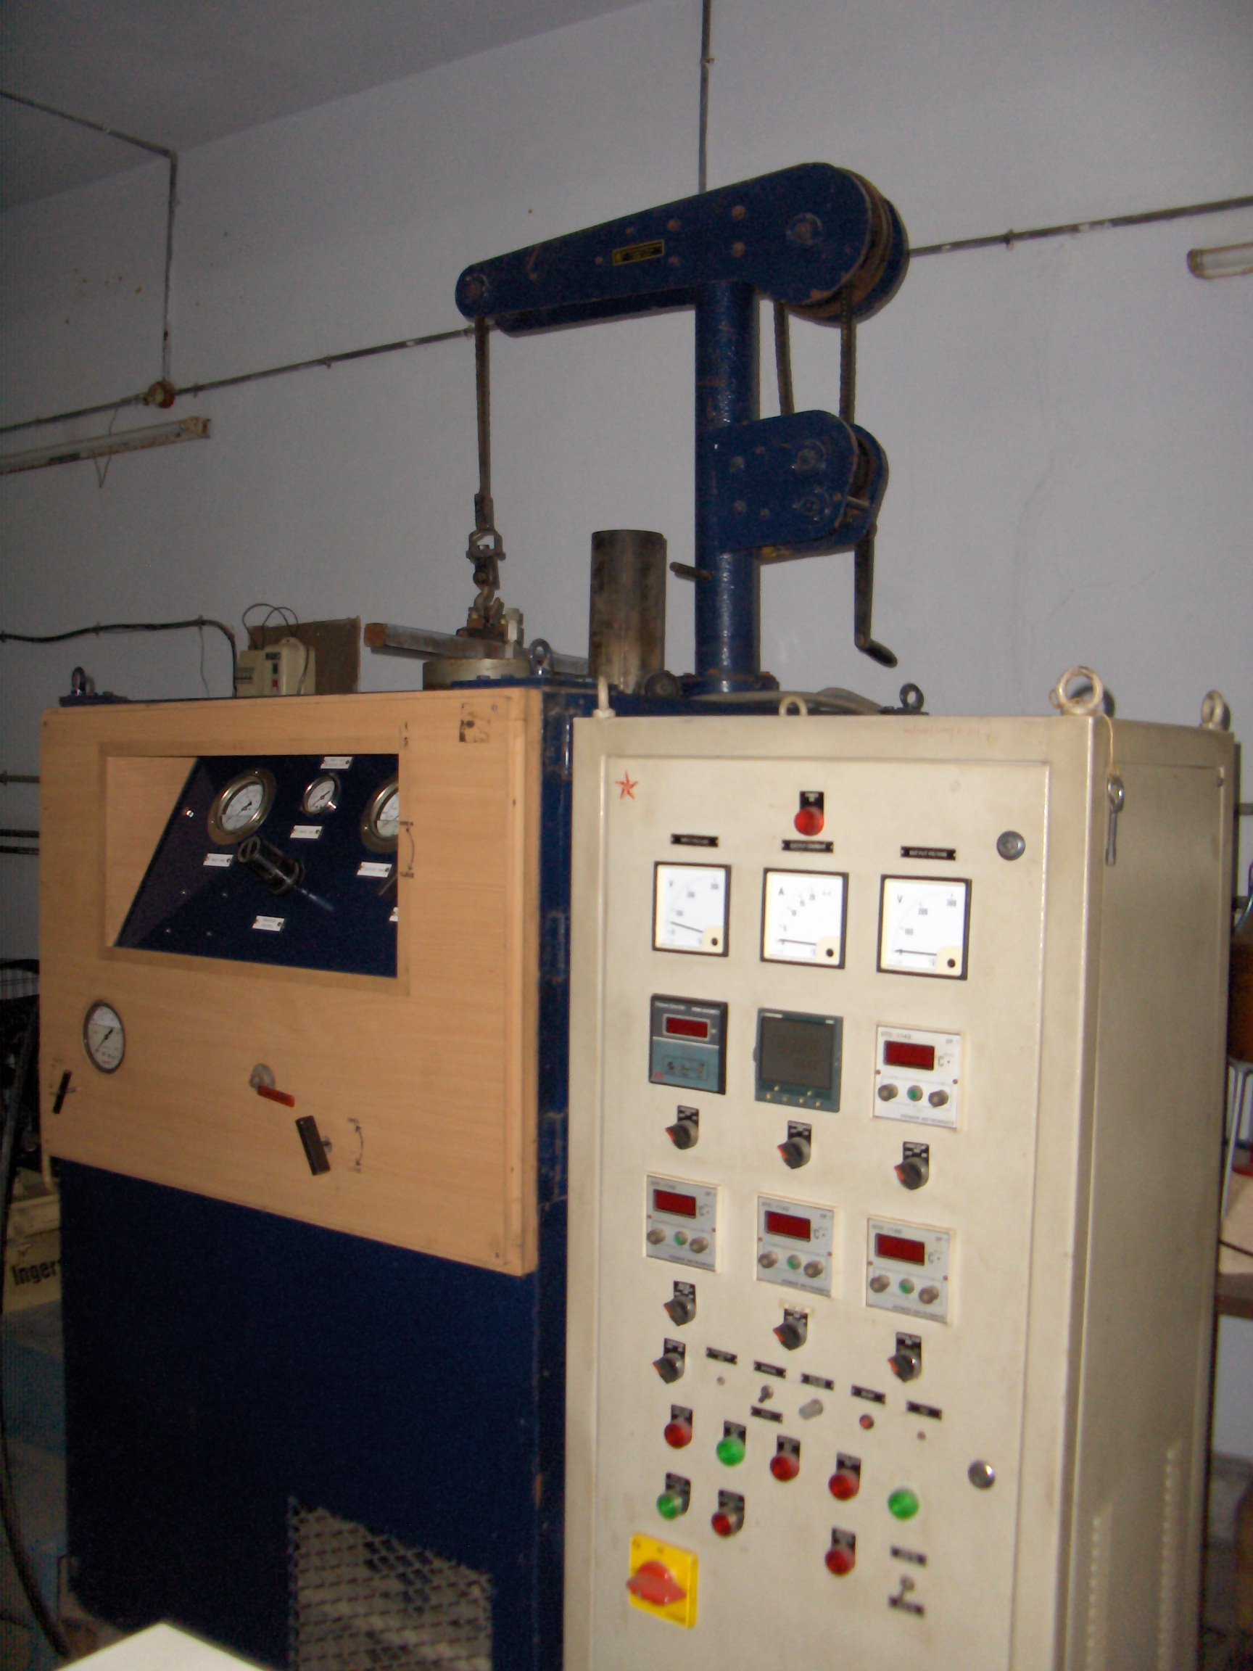
Hot Isostatic Pressing (HIP) upto 550ºC

